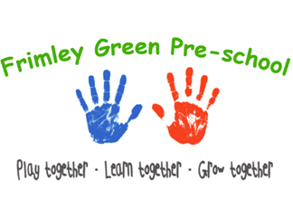
Early Years Practice and Procedures – Sleep
At Frimley Green Pre-School our children generally do not need to sleep. On occasion children do fall asleep. Our sleep and rest procedures at Frimley Green Pre-School comply with the EYFS and the latest available safety guidance.

Young children
- Young children sleep on a nursery plastic stackable bed.
- Young children each have a place to put their clothes and shoes in, and in which they keep any special toy, book, or comforter that they need for sleep.
- Nappies are changed and heavier clothing is removed.
- Hair accessories with parts that may come lose or detached and pose a choking hazard are removed before sleep/rest time.
- A separate area of the room is made as quiet as possible.
- Young children are settled by their key person. They are soothed to sleep. Key persons may stroke or very gently pat children.
- Sleeping children are always supervised within sight and hearing of staff.
- If children fall asleep in-situ it will be necessary to move or wake them to make sure they are comfortable, they are not left to sleep on bean bags. Sleeping children are regularly checked at least every ten minutes and are within sight and/or hearing of staff. Hats and extra clothing are removed as soon as they are indoors or enter a vehicle.

Children asleep on arrival at the setting
- If a child arrives at the setting asleep, they are sensitively woken whilst the parent/carers are still present. Outdoor clothes are removed, and the child is settled on the nursery stackable bed, if they are still sleepy, but otherwise well.
- If a child does not show signs of going back to sleep after being woken, they are welcomed and settled into the session at their own pace.

Staff training
All staff are required to read Lullaby Trust Guidance on Safer Sleep and the NHS advice on sudden infant death syndrome.

Further guidance
Safer sleep – help for early years providers
- Safer Sleep for Babies (Lullaby Trust) www.lullabytrust.org.uk/safer-sleep-advice
- NHS safer sleeping information https://www.nhs.uk/best-start-in-life/baby/baby-basics/newborn-and-baby-sleeping-advice-for-parents/safe-sleep-advice-for-babies/
- Sudden infant death syndrome (SIDS) NHS guidance
- https://www.nhs.uk/baby/caring-for-a-newborn/sudden-infant-death-syndrome-sids/
- Ofsted staff deployment guidance
- Safer Sleep Awareness: A guide for Childminders, Foster Carers, Nannies and Nursery Settings (The Lullaby Trus

