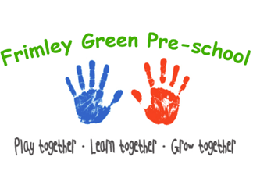

Health and Safety Procedures
Animals and Pets

Frimley Green Pre-School does not currently have any pets. We do on occasion have animal visits.
- Views of parents and children are considered when selecting an animal for the setting.
- Staff will be aware of any allergies or issues individual children may have with any animals/creatures.
- A risk assessment is conducted and considers any hygiene and safety risks posed by the animal or creature.
- Suitable housing for the animal is provided and is regularly cleaned and maintained.
- The correct food is offered at the right times and staff are knowledgeable of the animal’s welfare and dietary needs.
- Arrangements are made for weekend and holiday care for the animal/creature.
- There is appropriate pet health care insurance or other contingencies agreed and put in place to pay for veterinary care and the animal is registered with a local vet.
- All vaccinations and health measures such as de-worming are up to date if required,
- Children are taught correct handling of the animal and are always supervised.
- Children wash their hands after handling the animal and do not have contact with animal faeces, or soiled bedding.
- Members of staff wear single use vinyl/latex free gloves when cleaning/handling soiled bedding.
- Snakes and some other reptiles are not suitable pets for the setting due to infection risks.
- The supervisor will check with the committee/trustees before introducing a new animal into the setting.

Animals bought in by visitors.
On occasion Frimley Green Pre-School has visits from commercial petting farms, animal handling e.g., Zoo lab and we adhere to their advice and company policy.
- The owner of the animal/creature maintains responsibility for it in the setting.
- The owner carries out a risk assessment detailing how the animal/creature is to be handled and how any safety or hygiene issues will be addressed.
- In the correct season, Frimley Green Pre-School may purchase minibeasts such as caterpillars from a reputable source in order to observe their life cycle, e.g., Insect Lore. The creatures are kept in accordance with the above and guidelines from the providing company
- No dogs on the Government’s Banned Dogs list are to be brought on site at any time. All other dogs brought on site by parents/carers during arrival and departure times must be on the lead and under control. The pre-school staff reserves the right to request that a dog is not brought on site, if the animal is out of control, or likely to pose a risk.
- All dogs must be kept away from the entrance as some children may be frightened of animals. If staff are concerned that a family owns a dog which is on the ‘banned dog’s list, it is treated as a safeguarding concern and it is reported to the relevant authority and safeguarding procedures are followed.

Further guidance
Good Practice in Early Years Infection Control (Alliance 2009)
www.HSE.gov.uk
https://www.gov.uk/control-dog-public/banned-dogs

