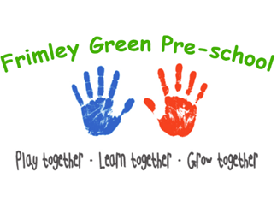
Working in partnership with parents/carers and other agencies policy

To be read alongside associated procedures in Working in partnership with parents and other agencies procedures.
Aim
We actively promote partnership with parents and recognise the importance of working in partnership with other agencies to promote the well-being of children and their families. This includes signposting parents to support as appropriate.

Objectives
- We believe that parents are children’s first and most enduring educators and our practice aims to involve and consult parents on all aspects of their child’s well-being.
- We also recognise the important role parents must play in the day-to-day organisation of the provision.
- We consider parents views and expectations and will give the opportunity to be involved in the following ways:
- sharing information about their child’s needs, likes, achievements and interests.
- settling in their child to the agreed plan according to our settling in procedures
- taking part in children’s activities and outings when required
- contributing with ideas or resources as appropriate to enhance the curriculum of the setting.
- taking part in early learning projects, sharing with educators’ knowledge and insights about their child’s learning
- contributing to assessment with information, photos and stories that illustrate how their child is learning within the home environment, taking part in day-to-day family activities.
- attending review meetings to discuss their child’s progression.
- taking part in planning, preparing, or simply participating in social activities organised within the setting.
- taking part with the pre-school committee to encourage the participation of parents in discussions about the day-to-day organisation of the setting, consulting about new developments and other matters as they arise.
- involvement in the review/reading of policies and procedures.
- Ofsted and setting contact details are displayed on the parent notice board for parents who have a complaint that cannot be resolved with the setting supervisor or committee chairperson in the first instance, or where a parent is concerned that the EYFS standards are not being maintained.
Partnership and signposting to other agencies
- We are committed to ensuring effective partnership with other agencies including:
- local authority early years services about the EYFS, training and staff development
- local programmes regarding children’s centres or the childcare and early education element of children’s centres
- social welfare departments regarding children in need and children who need safeguarding or for whom a child protection plan is in place.
- child development networks and health professionals to support children with disabilities and special needs.
- local community organisations and other childcare and early education providers
- Ofsted and setting contact details are made available to other agencies who have a complaint that cannot be resolved with the Setting Supervisor or the Pre-School Chairperson in the first instance, or where a parent is concerned that the EYFS welfare standards are not being maintained.
Legal references
Childcare Act 2006
Education Act 2011

