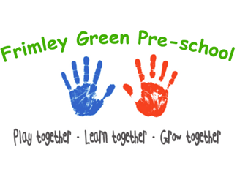
Early years practice procedures
Progress check at age two
- A template for completing the two-year-old progress check at age two is provided by Surrey Early Years.
- The key person is central to the progress check and must be the person completing it.
- Settings should take guidance from their local authority as to when the progress check at age two is completed. Surrey recommends that a two-year check is completed for a child between 26 and 35 months, the key person completes the check with in 6 weeks or before the child’s 3rd birthday if sooner.
- Once the timing of the child’s progress check is confirmed, parents/carers are invited to discuss their child’s progress at a mutually convenient time.
- The setting must seek to engage both parents/carers and make allowance for parents/carers who do not live with their child to be involved.
Completing the progress check at age two
- On-going observational assessment informs the progress check and must be referred to.
- Children’s contributions are included in the report. Staff must be ‘tuned in’ to the ways in which very young children, or those with speech or other developmental delay or disability, communicate/
- Where any concerns about a child’s learning and development are raised these are discussed with the parents/carers, the SENCo and the setting supervisor.
- If concerns arise about a child’s welfare, they must be addressed through Safeguarding children, young people and vulnerable adults’ procedures.
- The key person must be clear about the aims of the progress check as follows:
- to review a child’s development in the three prime areas of the EYFS
- to ensure that parents have a clear picture of their child’s development
- to enable educators to understand the child’s needs and, with support from educators, enhance development at home
- note areas where a child is progressing well and identify any areas where progress is less than expected describe actions the provider intends to take to address any developmental concerns (working with other professionals as appropriate).

