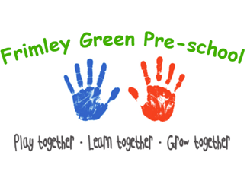
Health and safety procedures
Animals and pets
Frimley Green Pre-School does not currently have any pets. We do on occasion have animal visits.
- Views of parents and children are considered when selecting an animal for the setting.
- Staff will be aware of any allergies or issues individual children may have with any animals/creatures.
- A risk assessment is conducted and considers any hygiene and safety risks posed by the animal or creature.
- Suitable housing for the animal is provided and is regularly cleaned and maintained.
- The correct food is offered at the right times and staff are knowledgeable of the animal’s welfare and dietary needs.
- Arrangements are made for weekend and holiday care for the animal/creature.
- There is appropriate pet health care insurance or other contingencies agreed and put in place to pay for veterinary care and the animal is registered with a local vet.
- All vaccinations and health measures such as de-worming are up to date if required,
- Children are taught correct handling of the animal and are always supervised.
- Children wash their hands after handling the animal and do not have contact with animal faeces, or soiled bedding.
- Members of staff wear single use vinyl/latex free gloves when cleaning/handling soiled bedding.
- Snakes and some other reptiles are not suitable pets for the setting due to infection risks.
- The supervisor will check with the committee/trustees before introducing a new animal into the setting.

Animals bought in by visitors.
On occasion Frimley Green Pre-School has visits from commercial petting farms, animal handling e.g., Zoo lab and we adhere to their advice and company policy.
- The owner of the animal/creature maintains responsibility for it in the setting.
- The owner carries out a risk assessment detailing how the animal/creature is to be handled and how any safety or hygiene issues will be addressed.
- In the correct season, Frimley Green Pre-School may purchase minibeasts such as caterpillars from a reputable source in order to observe their life cycle, e.g., Insect Lore. The creatures are kept in accordance with the above and guidelines from the providing company

Further guidance
Good Practice in Early Years Infection Control (Alliance 2009)
www.HSE.gov.uk

Policy adopted 29th Nov 23
Reviewed by ……………………………… Date……………………………………………
Reviewed by……………………………….Date……………………………………………..
Reviewed by ………………………………Date………………………………………………

