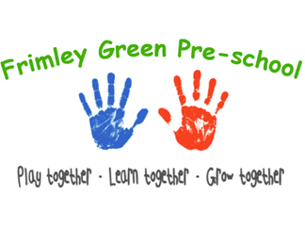

Frimley Green Pre-school Healthy Eating and Lunch Box Policy
Please read alongside our Food and Nutrition Policies.
The Overall aim of this policy
Our aim is to ensure that all packed lunches brought from home and consumed in pre-school provide children with healthy and nutritious food that is similar to food served in schools, which is now regulated by national standards.
Our setting is a suitable, clean, and safe place for children to be cared for, where they can grow and learn. We meet all statutory requirements for food safety and fulfil the criteria for meeting the relevant Early Years Foundation Stage Safeguarding and Welfare requirements.
- We provide nutritionally sound snacks which promote health and reduce the risk of obesity and heart disease that may begin in childhood.
- Following dietary guidelines to promote health also means taking account of guidelines to reduce risk of disease caused by unhealthy eating.
- Parents and carers share information about their children’s particular dietary needs with staff when they enrol their children and on an on-going basis with their key person. This information is shared with all staff who are involved in the care of the child.
- Care is taken to ensure that children with food allergies do not have contact with food products that they are allergic to.
- Risk assessments are conducted for each individual child who has a food allergy or specific dietary requirement.
- It is important that the children can be as independent as possible when eating their lunch. To reduce safety concerns/risks, particularly with regards to choking, children must be able to sit on a chair at the table to eat their lunch. We would encourage families to support the pre-school by working on this at home.

Frimley Green Pre-school recognises that our children come from diverse home backgrounds, cultures, ethnic and faith groups. We aim to meet the needs of all children and ensure equality of provision whilst taking account of this diversity and difference.
We understand that some children are ‘fussy’ eaters and that it is a major step to get some children to eat anything at all. We would like parents to let us know if this is the case, so that we can deal with such children sensitively. Offering praise and encouragement for what the child has eaten.
We will encourage all children to eat and drink as much of their lunch as possible so please do not overfill lunchboxes as this can be overwhelming for the children and difficult for the staff to gauge how much each child has eaten. Portion sizes are available on government and NHS websites.
We will provide a safe, healthy, and appealing eating environment for children eating packed lunches and ensure fresh drinking water is available at all times.
As fridge space is not available in Pre-school, parents are advised to send in packed lunches in a clearly named bag/box with an ice pack or food that does not require refrigeration.
We do not have the facility to warm up individual packed lunches for children.
It is important that the food inside the lunch box is prepared to reduce the risk of choking i.e., items such as tomatoes, strawberries, grapes etc. are chopped lengthways into quarters. Carrots, celery, cheese, and cucumber are cut into battens and not circles that could obstruct a child’s airway. Advice regarding food preparation for children is available on government websites.
Snack will be provided by each child bringing in an item of healthy snack each week on the first day they attend Pre-school. This will then be shared between all the children.
In our Contingency Framework we will provide snack and prepare/serve if it should become necessary or advised to do so e.g. outbreak of Covid.

Water/Milk
All children will have access to fresh drinking water throughout each day.
Milk and water are available at snack time.

The following guidelines for snacks and lunchbox contents may help parents and ensure health and equality for all children.
Packed lunches may include (advice available on government and NHS websites):
- At least one portion of fruit and or vegetable
- Meat, fish, or other source of non-dairy protein (e.g., lentils, chickpeas)
- A sandwich that includes a savoury filling (e.g., egg, tuna, cheese, cooked meat)
- A starchy food such as bread, pasta, rice, noodles
- Dairy food such as cheese, yogurt, fromage frais
- A biscuit not coated in chocolate.
- Crisps (baked or other low-fat options if possible) or other such snack such as seeds, breadsticks etc.
- Eating utensils if necessary (labelled with name)

Packed lunches should avoid:
- Confectionery such as chocolate bars, chocolate coated biscuits and sweets.
- Sausage rolls and pies should only be included occasionally.
- Fizzy drinks.

Nuts and nut products (e.g., peanut butter) should never be sent to Pre-School because of allergy concerns. Neither are children allowed to share food items for this same reason.
Please no chocolate or sweets.
On a daily basis, the staff in Pre-school will see what children have in their lunch boxes whilst supervising at lunch time. This is an opportunity for them to talk with the children about their lunchboxes and to encourage healthy eating and drinking. However, we may send parents a reminder of this policy if lunchbox contents regularly fall short of the expectations in this policy.
It is not our intention to tell parents what and how they should be feeding their children, and we will not do so, but we want to work with parents to educate our children about healthy dietary choices so that they can make their own informed choices independently when they are older.
If your child has not eaten enough of their lunch, we will wrap it up and send it home in their lunch box in order for you to see. Please place liquid items such as yoghurt into a resealable pot to avoid the unfinished contents leaking inside your child’s lunch box.
Due to the number of children with food allergies and intolerances, we request that food treats are not sent into pre-school to celebrate birthdays. We will celebrate your child’s birthday with their friends and provide a birthday book.

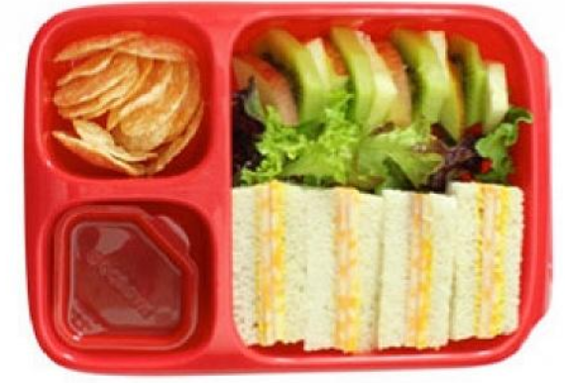

Our Commitment to Sustainability: Litter-Free Lunches
At Frimley Green Pre-School, we are committed to creating a more sustainable future for our children. As part of this effort, we are encouraging litter-free packed lunches to help reduce the amount of single-use packaging and waste in our setting.
What is a litter-free lunch?
A litter-free lunch is one that produces as little waste as possible. This means using reusable containers, avoiding individually wrapped items, and minimising plastic packaging.
Here are some easy ways to help pack a litter-free lunch:
- Use reusable lunchboxes and containers instead of plastic bags, tin foil or cling film.
- If a sandwich is in a plastic container, it doesn’t also need to be wrapped up in foil or cling film.
- If you like to wrap sandwiches – use a reusable sandwich bag or a beeswax wrap that can be reused instead.
- Pack drinks in a reusable water bottle rather than juice boxes or pouches.
- Decant yoghurt into a resealable pot (this saves unfinished contents leaking into the lunch box).
- Buy crisps/snacks in bulk and portion them into small containers instead of using individually wrapped items (this also saves money!)
- Choose whole fruits instead of pre-packaged fruit cups or bars.
We appreciate your support in helping us teach the children the value of caring for our environment.
Please remember to cut any small whole fruits—such as grapes, cherry tomatoes, blueberries etc. into halves or quarters to help prevent choking

Further advice will be distributed as necessary to parents via the weekly updates/newsletters/Facebook/notice board.
Further information can be found on government and NHS websites.
Legal references
Regulation (EC) 852/2004 of the European Parliament and of the Council on the hygiene of foodstuffs.
Food Information Regulations 2014
The Childcare Act 2006

Amended on 1st September 2025

