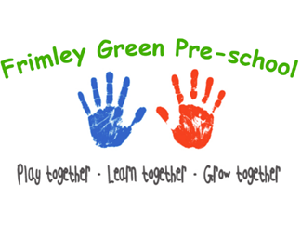
Early years practice procedures
Prime times – The role of the key person
‘Each child must be assigned a key person’ (EYFS 2024)
Young children need to form a secure attachment to key person when they join Frimley Green Pre-School to feel safe, happy, and eager to participate and learn.
The key person role
- A key person builds an on-going relationship with the child and their parents/carers and is committed to that child’s well-being while in the setting.
- Every child that attends is allocated a key person before they begin settling in - it is not the responsibility of the child to choose their own key person.
- As we are a small team of staff at Frimley Green Pre-School, we are all able to act as a back-up key person if the allocated key person is absent/unwell .
- The key person conducts the progress check at age two for their key children.
- The role is fully explained to parents/carers on induction and the child’s key person is introduced.
- The key person is central to settling a child into the setting. The key person explains the need for a settling in process and agrees a plan with the parents.
- Shift patterns and staff absence can affect a child who is just settling in; where possible, settling in should be matched to when the key person is on duty.
- The number of children for each key person considers the individual needs of children and the capacity of the key person to manage their cohort.
- A key person profile is handed out to each family.
- The key person spends time daily with his or her key group to ensure their well-being.
Parents/carers
- Key persons are the first point of contact for parents regarding matters concerning their child and any concerns parents/carers may have been addressed with the key person in the first instance.
- Key persons support parents/carers in their role as the child’s first and most enduring educators.
- The key person is responsible for the child’s developmental records, completing the progress check at age two, and for sharing information about progress with the child’s parents/carers.
Learning and development
- The key person helps to ensure that every child’s learning and care is tailored to meet their individual needs. This is achieved through regular observation and assessment of children, using information gathered about their achievements, interests and learning styles to plan for each individual child’s learning and development.
- If a child’s progress in any of the prime areas gives cause for concern, the key person must discuss this with the setting supervisor or SENCO and the child’s parents/carers.
Prime times
The key person will maintain other responsibilities for key children including administering medication.
Safeguarding children
- The key person has a responsibility towards their key children to report any concern about their development, welfare, or child protection matter to the setting manager and to follow the procedures in this respect.
- Regular supervision with the supervisor or deputy provides further opportunities to discuss the progress and welfare of key children.
- All other staff members at the pre-school have a duty likewise.
Further guidance
Being a Key Person in an Early Years Setting (Alliance Publication)

